Project Organizational Breakdown Structure (OBS) Template
This template enables you to record the unique organizational structure needed for your project. It will need to match the operational requirements of the project and include every facet required for its performance and to ensure the attainment of the project objective.
Your OBS shows the functional division of the various organizations or third parties involved in the performance of the project including the individuals who will produce the work packages. Within its structure a reader will be able to discern:
- Who or which unit is accountable for a work package.
- Who or which unit is responsible for producing a work package.
Through the iterations of the project OBS the organization will develop the most efficient project structure that takes into account the availability plus the capabilities of all resources in attaining the project goal. This process also identifies the management control points within the project structure.
How to Use this OBS Template
Click on the blank organizational chart shown in the following page and edit the lettered boxes and levels so that they reflect the needs of your project and its organization. The notepad icon in the top left-hand corner must be clicked on to open up the editing box that allows you to alter the letters in each box to reflect your project’s OBS.
For very complex projects you may need to copy this diagram to an additional page to ensure clarity and understanding of the project organizational structure.
Project  Working Title: | Project Description: |  |  |  |  |  |  |  | Version:  Date:
Project Contact tel:  Sponsor: email: |  |  |  | Plan Contact tel:  Author: email: |  |  | Organization:
Project Organizational Breakdown Structure (OBS) Approval
Printed Name & Job Title |  | Project Role |  |  | Signature |  |  | Date Approved
 |  | Project Sponsor
Circulated to:
-  -  -  - |  |  | -  -  -  - |  |  | -  -  -  -

Project Organizational Breakdown Structure (OBS)

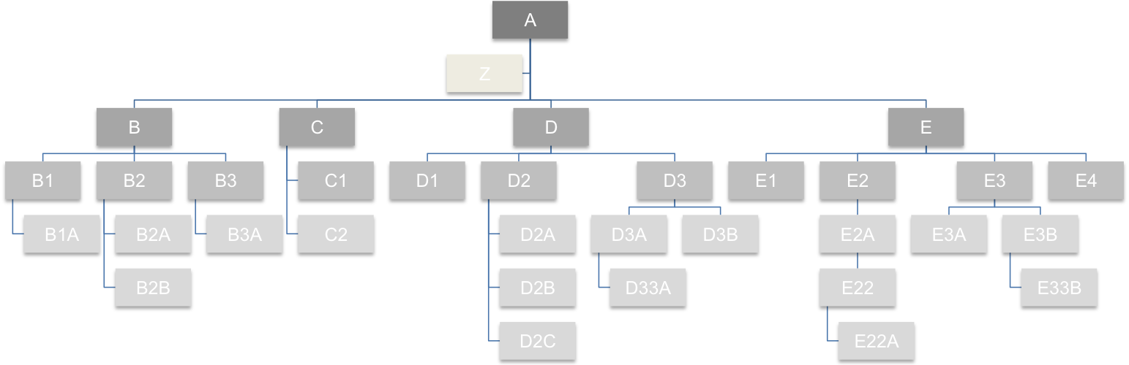

Individual | WBS Id | WBS Description | Resources | Dates Required | Project Budget Ref. | $ Costs

Appendix A – Version History
Version history of this document is recorded here. For each new and approved version the reasoning behind its creation are described below
Version  Number | Name of Implementation Author |  | Date Revised | Approved by | Date Approved | Reasoning behind new version
1.0
Appendix B – Glossary of Project Terms
Each project uses standard acronyms and develops their own for the ease of communication. It is important to record them in this plan to ensure clarity of description and terminology is consistent.
Acronym / Term |  | Standard or Project Definition
PMO |  | Project Management Office

Appendix C – Documentation References
Any professionally managed project has extensive documentation the purpose of this appendix is to record which documents (plus the version used, if applicable) have been used in the production of and conjunction with this document.
ISBN / Reference / Version | Document | Author
Project Management Plan
Stakeholder Register

