Risk Breakdown Structure (RBS) Template
This template enables you to create a hierarchical list of all the risks that affect your project. The purpose of the Risk Breakdown Structure (RBS) is to make sure that all project risks are decomposed into manageable chunks. Each risk is broken down into chunks that a practical to action and allow an appropriate mitigation strategy to be adopted.
It allows you to assign a unique ID to each risk and its associated category as well as indicate the type of strategy that will be adopted to mitigate its impact on the project. This document will be used in conjunction with other key project documents throughout the lifespan of the project such as risk register, assumptions log, issue log, risk analysis, change request register, risk log and its own management plan.
For many projects there are two main categories, external and internal or project related risks that can then be broken down into greater detail as it relates to the purpose of the project. In some instances it is more appropriate to use four categories for example project management, technical, organizational and external.
There are various ways the RBS can be represented for example as a table, flow or hierarchical chart (as shown in appendix A)
NOTE: This process follows a similar one to that of the Work Breakdown Structure (WBS).
Project  Working Title: | Project Description: |  |  |  |  | Version:
Project Sponsor:  Tel: Email: |  |  | Project Manager:  Tel: Email: |  |  | Date:
Risk Breakdown Structure (RBS) Approval
Printed Name & Job Title |  | Project Role |  |  | Signature |  | Date Approved
Circulated to:
-  -  -  - |  |  |  | -  -  -  -

Negative Risk Breakdown Structure (RBS) |  |  | Mitigation Options
ID | Category | Description | Risk Avoidance | Risk Sharing | Risk Reduction | Risk Transfer

Positive Risk /(Opportunity) Breakdown Structure (RBS) |  |  | Mitigation Options
ID | Category | Description | Accept Risk | Exploit Risk | Share Risk | Enhance Risk

Appendix A – RBS Hierarchical Chart

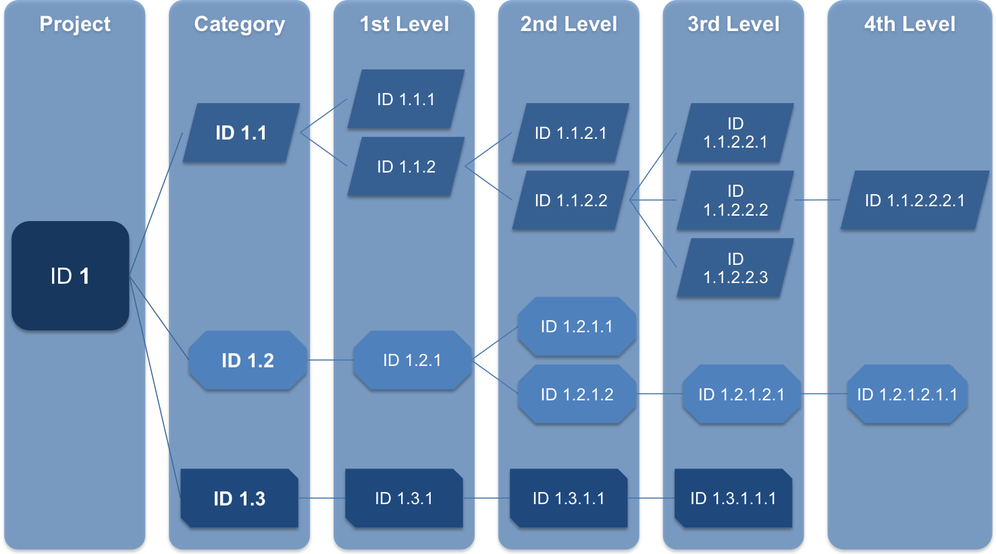

Appendix B – Version History
This appendix records the version history of this plan. For each new and approved version the reasoning behind its creation are described below
Version  Number | Name of Implementation Author |  | Date Revised | Approved by | Date Approved | Reasoning behind new version
1.0
Appendix C – Glossary of Project Terms
Each project uses standard acronyms and develops their own for the ease of communication. It is important to record them in this plan to ensure clarity of description and terminology is consistent in every communication.
Acronym / Term |  | Standard or Project Definition
PMO |  | Project Management Office

Appendix D – Documentation References
Any professionally managed project has extensive documentation the purpose of this appendix is to record which documents (plus the version used, if applicable) have been used in the production of and conjunction with of the communications management plan.
ISBN / Reference / Version | Document | Author
Risk Management Plan
Assumption Log
Risk Analysis
Risk Log
Impact Analysis

