**Productivity (and not efficiency)**

The seminal book on lean, *The Machine that Changed the World*, spent many words, tables, and figures on the subject of productivity (as well as, of course, quality).

**Why?**

Productivity is one of the critical few measures that reflect the “leanness” of a process, value stream or enterprise. It captures how effectively an organization uses its resources, and it’s usually a meaningful way to compare performance over time and between entities.

Productivity is the *ratio between the outputs of goods or services and the inputs applied for the purpose of that output.* There are two typical applications of this ratio – single-factor productivity and multi-factor productivity. Labor is often the single factor and is referred to as labor productivity. Another popular single factor is machine productivity.

Labor productivity captures the output per labor input. Outputs are often units, but can also be reflected in the dollar value of the labor.

Multi-factor productivity, as the name implies, takes into account multiple inputs; typically labor and resources such as capital equipment, energy and material. The common unit of measurement for multi-factors is almost exclusively dollars.

Example productivity ratios include:

* units per labor hour
* units per person per hour
* units per labor dollar
* sales per person
* units per machine hour
* units per square foot
* sales per square foot
* total processing cost per unit

The number of different productivity measurement is limited only by the imagination. But, like anything, the measurement must be pragmatic and help drive the proper lean behavior with a focus on period over period improvement within the process, value stream and enterprise.

The formula and ABC Company example(s) follow:

[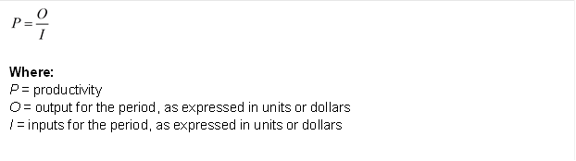](http://leanmath.com/blog/wp-content/uploads/2013/04/productivity-1a.png)

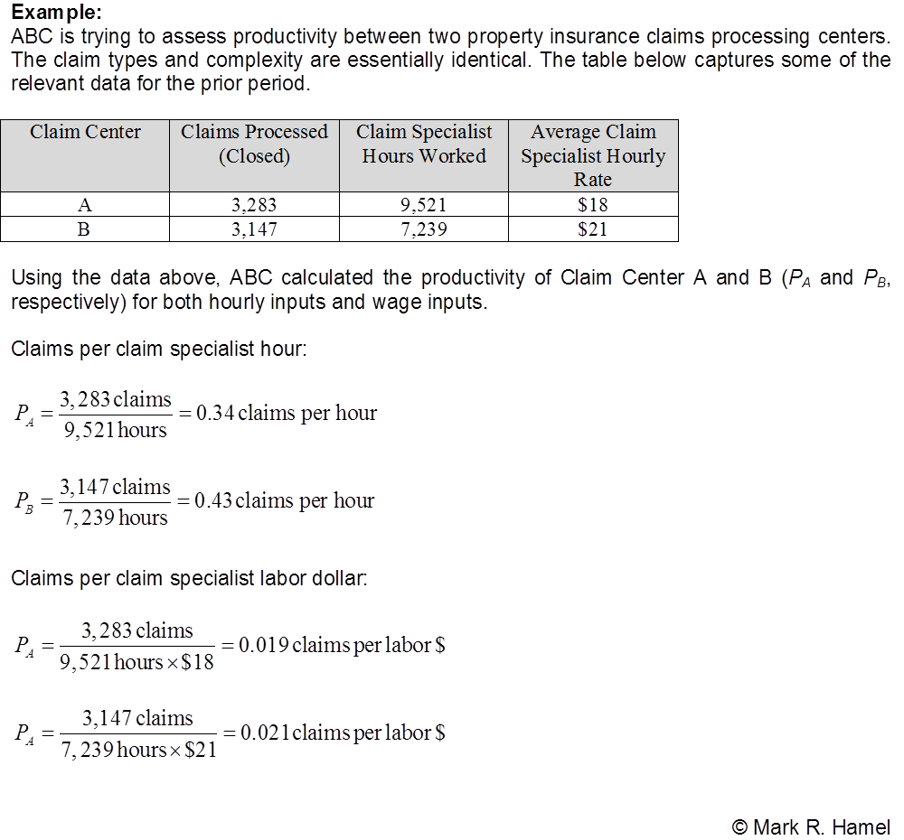 Consider the following:

|  |  |  |  |  |  |
| --- | --- | --- | --- | --- | --- |
| Type | Quantity | $/Unit | $/Hour | Labor Hours | Employees |
| Product X | 4000 | $8,000 | $12 Per Hour | 20000 | 127 |
| Product Y | 6000 | $9,500 | $14 Per Hour | 30000 | 191 |

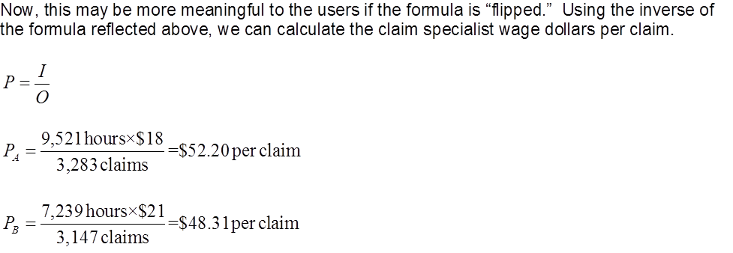

Consider the following:

|  |  |  |  |  |  |
| --- | --- | --- | --- | --- | --- |
| Type | Quantity | $/Unit | $/Hour | Labor Hours | Employees |
| Product X | 4000 | $8,000 | $12 Per Hour | 20000 | 127 |
| Product Y | 6000 | $9,500 | $14 Per Hour | 30000 | 191 |

**How about in labor Productivity in Dollars using number of Units sold?**

*Car X: [(4,000 * $8,000) / (20,000 * $12)] = $133.33 / Car  
Car Y: [(6,000 * $9,500) / (30,000 * $14)] = $135.71 / Car*

**Some other things to think about:**

* Understanding productivity is important. However, lean practitioners also distinguish between local and total (think “system”) productivity. So, while a cell or department’s productivity level is important, the total value stream is even more critical.
* Don’t be fooled! Understand the difference between real and apparent productivity:

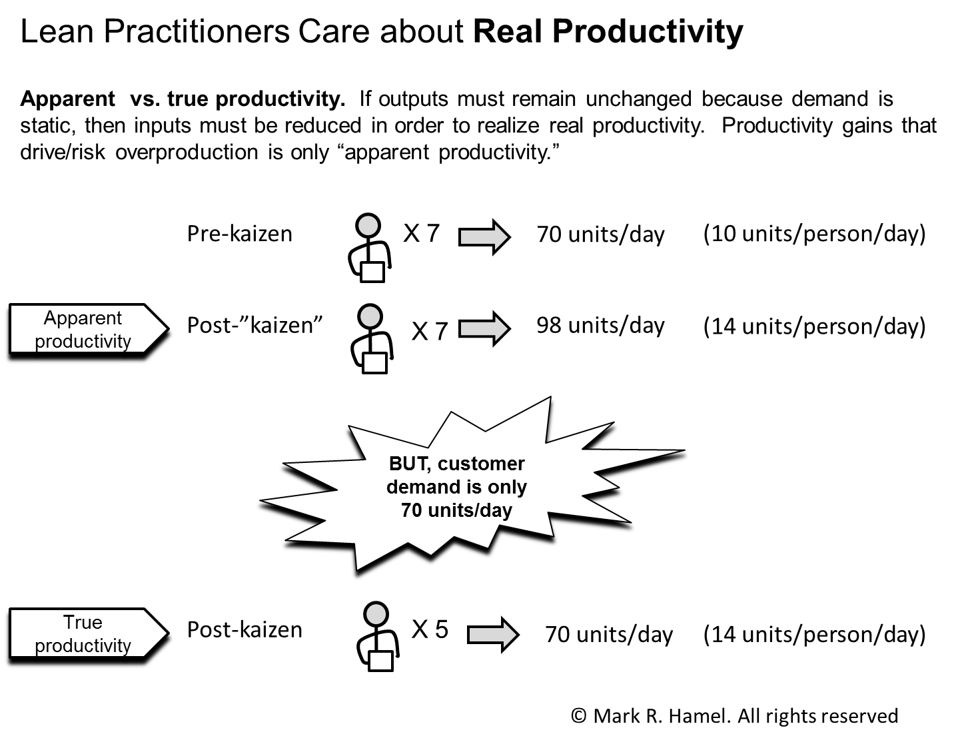

* When comparing productivity rates between lines, cells, value stream, locations, etc. it is important to understand relative work content. If work content varies substantially between areas, the productivity comparison may be misleading and require the use of common units.
* “Underutilized” inputs can distort productivity calculation results. For example, abnormally low demand can cause productivity to plummet. In such a situation, it may make sense to *also* calculate labor productivity only using the hours which the operators were working (other hours may have been heavily invested in cross-training and improvement activities).

**Efficiency (and not productivity)**

Many folks use the terms efficiency and productivity interchangeably.  They are not interchangeable. They are not equivalent.

 Heck, they’re not even synonyms – even though Thesaurus.com thinks so.

Technically, productivity is a ratio of (good) outputs to inputs and efficiency is the ratio of actual output to standard output. Lean practitioners are typically and more appropriately concerned about productivity. As the famous Art Byrne, former CEO of Wiremold, said, “Productivity = Wealth.”

BUT, in this post, we are talking about efficiency! And it’s important to understand the basic math around efficiency.

Efficiency is the ratio, typically reflected as a percentage, of actual output to the standard expected output. The measurement therefore provides insight into how well a resource(s) is performing relative to a standard.

Lean practitioners know that traditional standards are often not well maintained and do not always closely reflect reality. Accordingly, efficiency measurements may provide an inaccurate view of performance and may mask improvement opportunities. Standard work rigor, integrated with kaizen, should help reduce these risks and appropriately focus the organization.

Efficiency ratios can be categorized as follows (APICS Dictionary, 13th ed.):

1. actual units produced or processed to the standard rate expected within a time period (hour, day, week, etc.),
2. standard hours produced or “earned” compared to actual hours worked, and
3. actual dollar volume of output to a standard dollar volume of output within a time period.

The math follows:

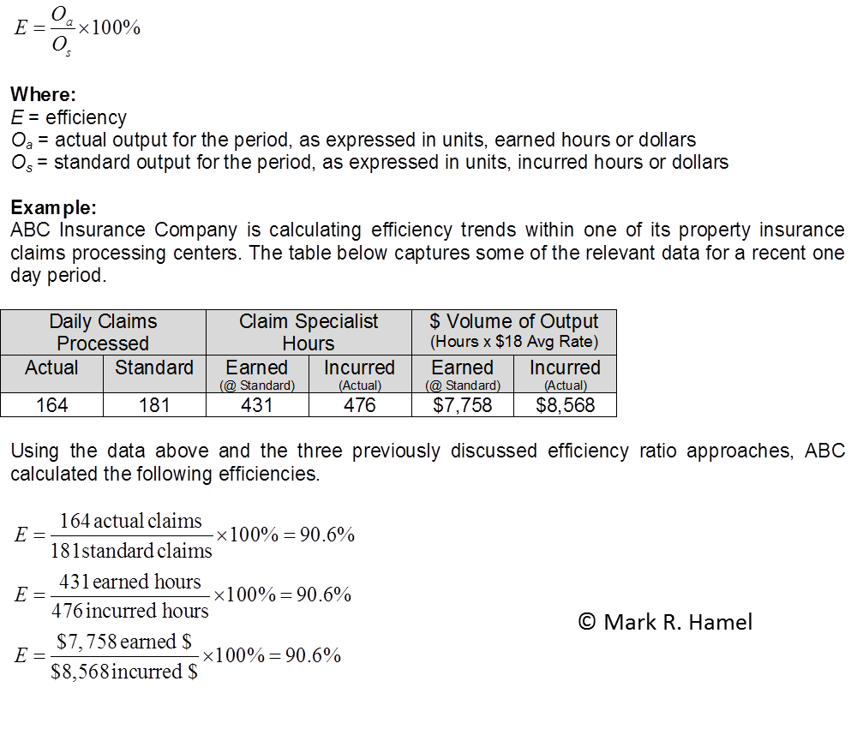

# [Process Capacity Sheet Math](http://leanmath.com/blog/2013/09/24/process-capacity-sheet-math/)

The process capacity sheet, also known as a table of production capacity by process or production capacity chart or process capacity table, is one of the three basic tools for establishing a standard operation. The other tools are the standard work combination sheet and standard work sheet. All three standard operations sheets are populated with data obtained through direct observation (as is the [time observation form](http://leanmath.com/blog/2013/09/12/time-observation-form-math/)).

The process capacity sheet, as the name implies, is for the purpose of determining a given process’ capacity for a shift, and thus its ability to meet takt time. This determination is made through the calculation of each process step’s capacity, considering the available time per shift, completion time, and tool change time, and other factors, as required, for each single work piece. The process’ overall capacity is defined by the bottleneck step, which may be addressed through things like changeover time reduction and machine and/or operator cycle time reduction. Some versions of the sheet, like the one below, also provide fields for the number of required operators to satisfy takt time and calculated maximum output.

The figure below shows a populated process capacity sheet, along with alpha “call-outs” by which the math is explained.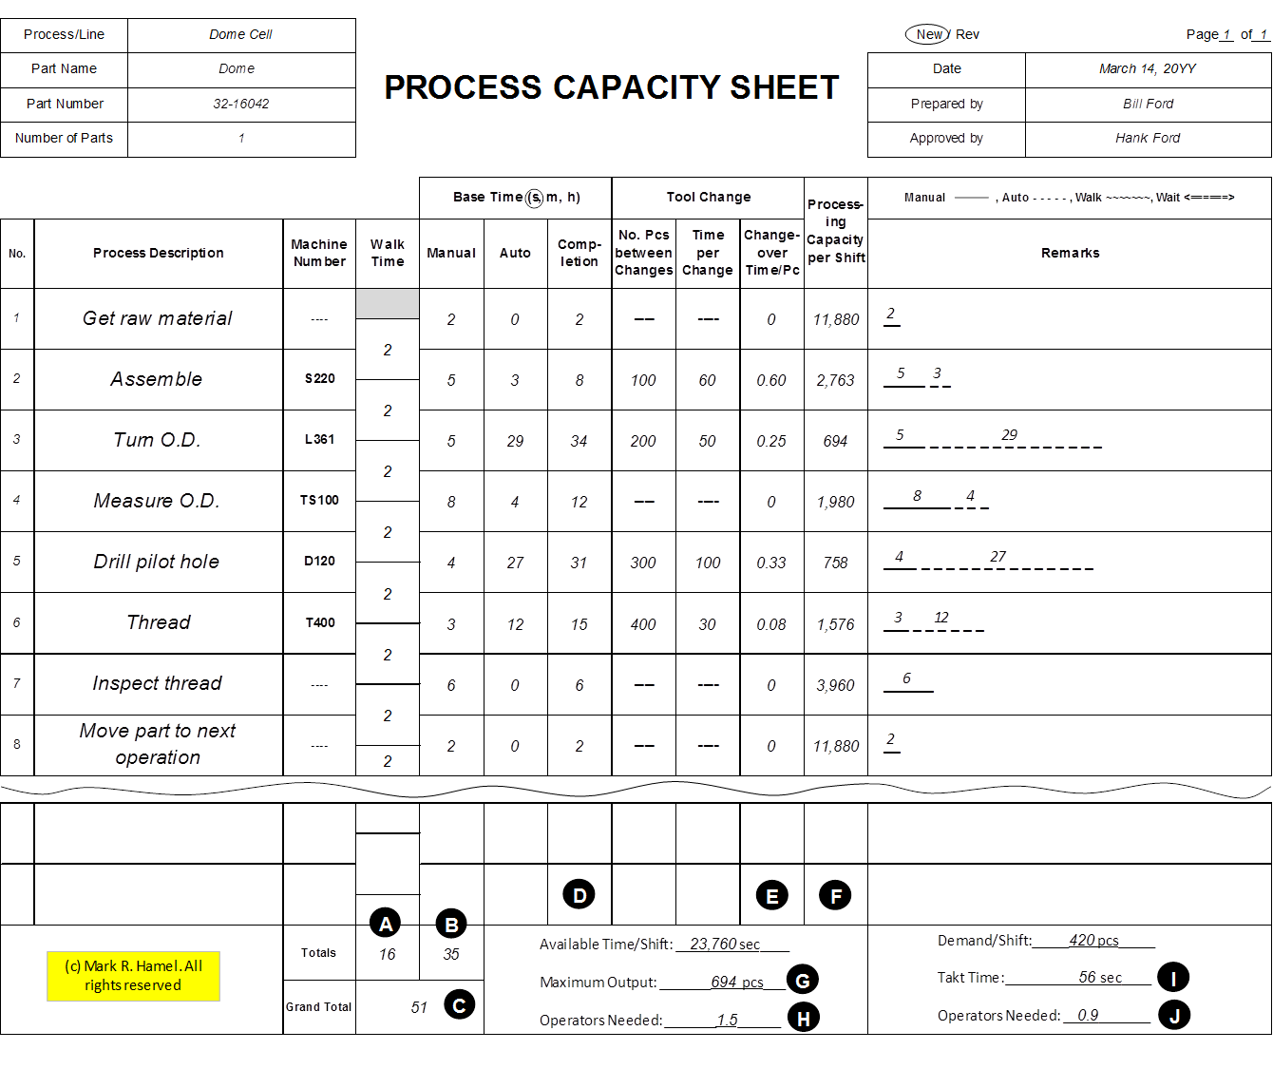

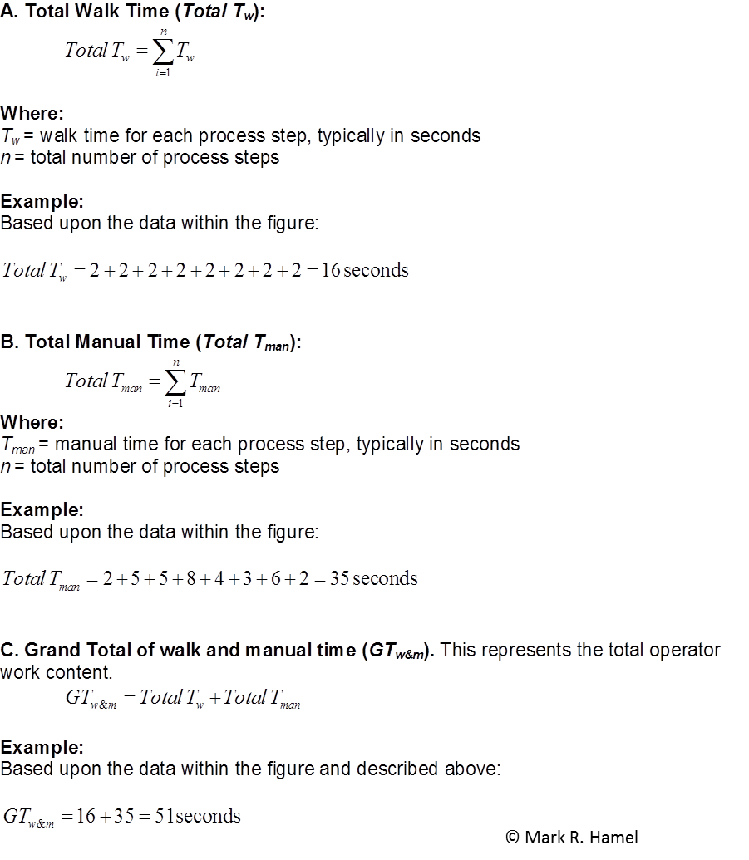

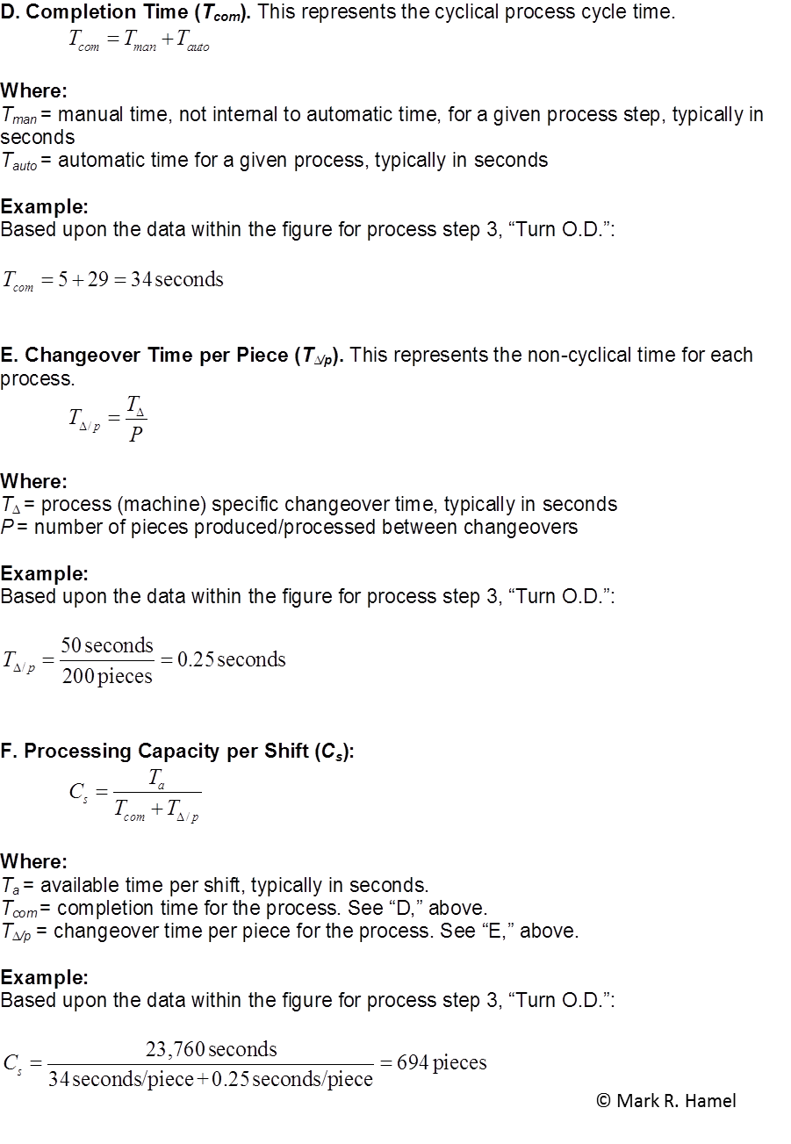

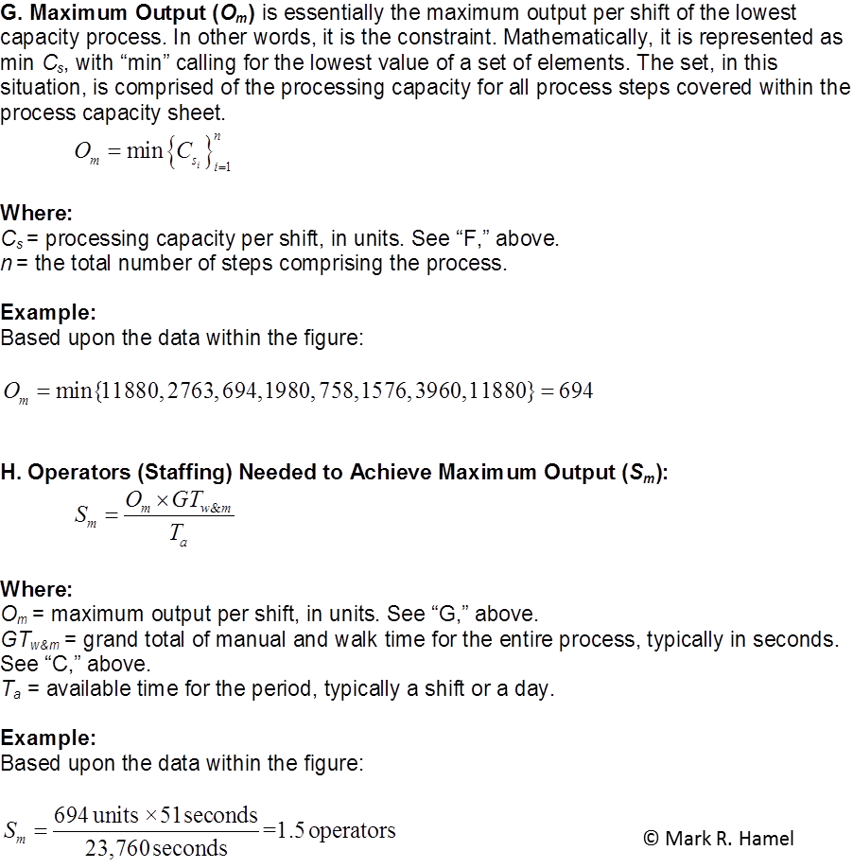

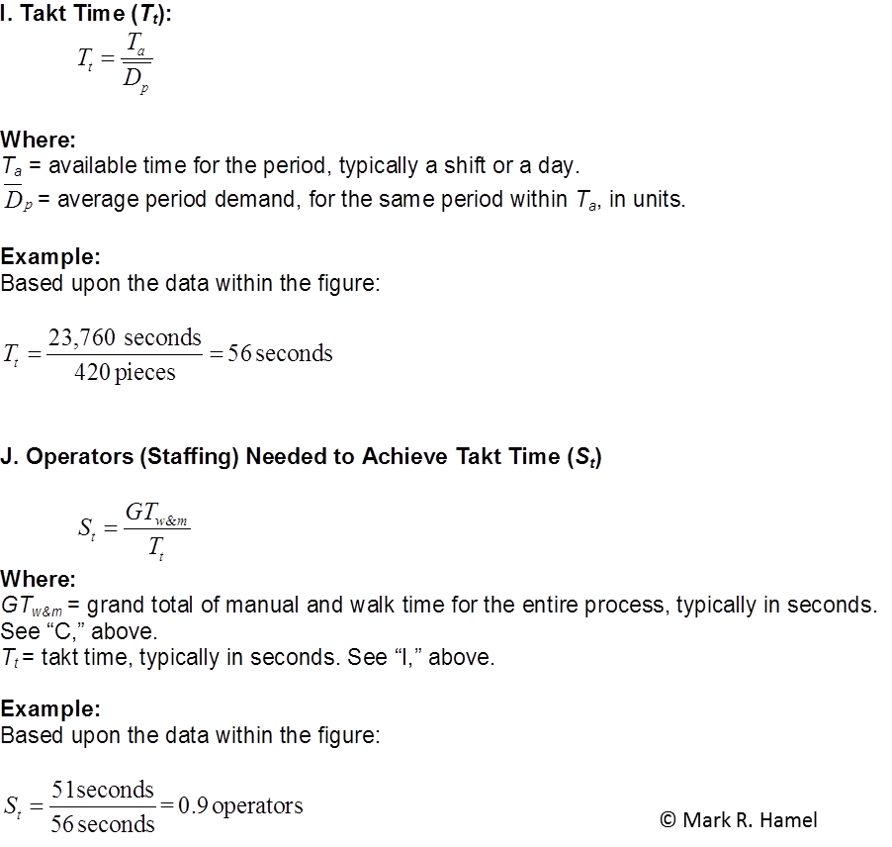

# [Line Balance Rate](http://leanmath.com/blog/2013/03/14/line-balance-rate/)

The operator balance chart, also known as a percent load chart, operator loading diagram, cycle time/takt time bar chart, or line balance analysis graph, provides the lean practitioner with insight into how equalized operation time is among the workers within a given process, line or cell. The line balance rate (LBR), and the related line balance loss rate (which is simply 100% minus the LBR), quantifies how well or poorly the line is balanced.

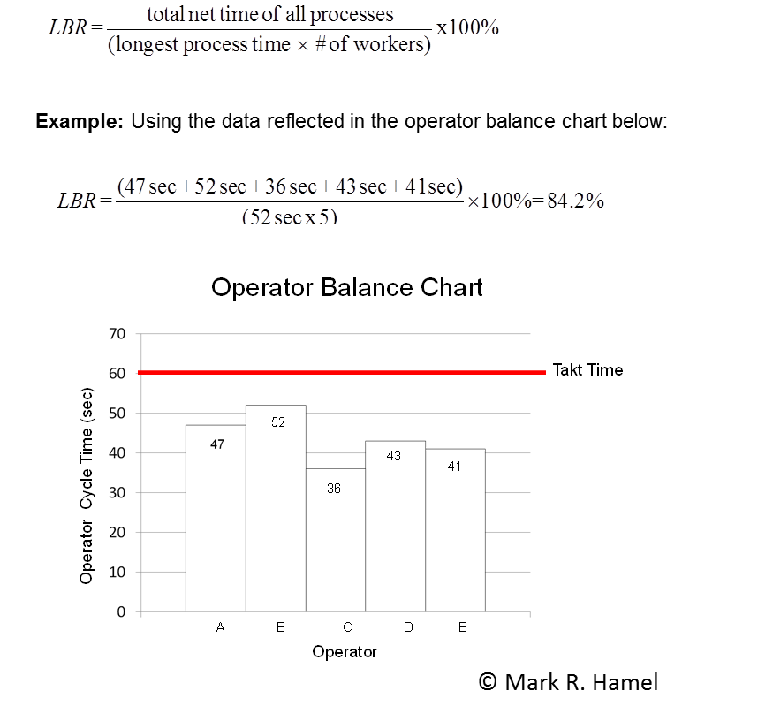

A lack of line balance routinely causes the waste of waiting and/or overproduction. It can also prompt over-processing during which operators, rather than engage in the blatant waste of waiting, conduct “apparent work.” Line imbalance is an enemy of continuous flow.

Some may ask, “What the heck do I do with this?” While there is not necessarily a magical LBR “bogey,” it’s definitely useful when developing standard work and comparing different balance scenarios.

Consider LBR a simple analytical tool. Use it when it makes sense.

# Weighted Average Cycle Time:

Weighted average cycle time (*Tcwa*), also known as “average weighted cycle time,” provides a representative average cycle time (*Tc*) within a mixed model environment. Varied models or services in a given cell, line or work area often have varied work contents due to different steps, duration of steps, sequence of steps, etc. Accordingly, the *Tc*‘s vary.

*Tcwa* can be calculated for operator cycle times, machine cycle times and effective machine cycle times. Often *Tcwa* is presumed to be operator related, but this is not always the case.

As we endeavor to maintain a *Tc* that is less than or, at most, equal to takt time (*Tt*), mixed models and their varying work content will likely have *Tc*‘s for some products or services that are below *Tt*, while others exceed *Tt*.*Tcwa* serves as an average proxy for *Tc* and can be the same as planned cycle time.

Clearly, change in product or service mix will change *Tcwa*. As the demand mix shifts to one with a greater proportion of *Tc*(s) that exceed the average, then*Tcwa* will approach and may exceed *Tt*. The lean practitioner must be aware of these dynamics and should proactively address the situation through reducing work content, optimizing balance between operators, adding additional operator(s) or lines, strategically applying/sizing FIFO lanes, etc.

The math follows.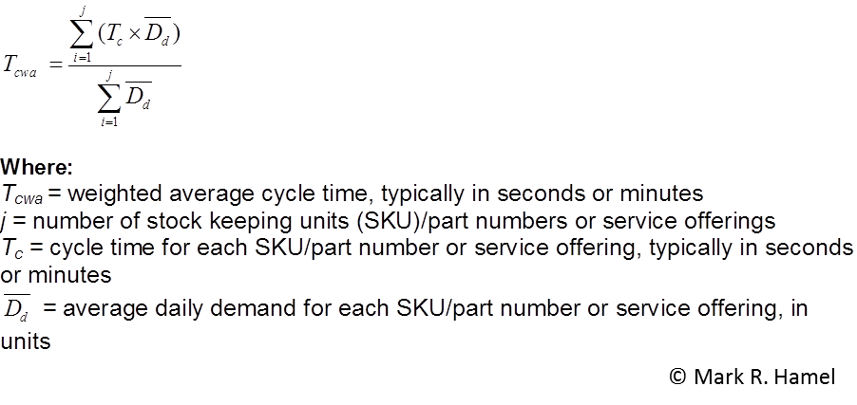

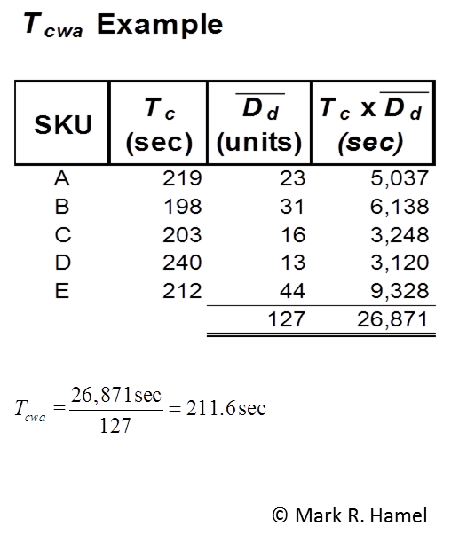

# Time Units:

# We’ve all encountered a “Duh” moment when we’re working with time units.

Many time the problem is that we forget that there really aren’t 100 seconds in a minute.

That would be the decimal trap.

For example, 4:17 as reflected on a time piece (a.k.a. stopwatch) does not equate to 4.17 minutes. If for some reason, decimals are preferred, like on the “bottom rung” of a value stream map’s lead time ladder, then 4:17 should be reflected as 4.3 minutes. Calculated as follows:

[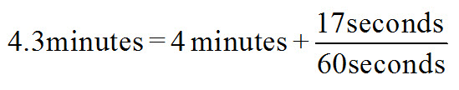](http://leanmath.com/blog/wp-content/uploads/2013/01/TimeUnits.jpg)

Another common error occurs when clock times are added or subtracted. This is again rooted in decimal confusion. For example, after recording cumulative times on a time observation form, the practitioner must then determine the discrete time for each observed step. This requires subtraction. The difference between 5:02 and 4:17 is not 0.85, rather it is 45 seconds.

I know that these errors seem pretty silly. But, I know that I’ve made them myself and I have seen folks that are newly introduced to direct observation and the use of time pieces make them – over and over again.

As business professionals, we take some important business concepts for granted. Today, we’ll explore two that are often confused with each other and see if I can offer a perspective that I hope will add some clarity or, at the very least, add some value to the conversation and debate.

Today we’ll discuss the difference and see how they are different through the evaluation of productivity and efficiency calculations.

Consider the following:

|  |  |  |  |  |  |
| --- | --- | --- | --- | --- | --- |
| Type | Quantity | $/Unit | $/Hour | Labor Hours | Employees |
| Product X | 4000 | $8,000 | $12 Per Hour | 20000 | 127 |
| Product Y | 6000 | $9,500 | $14 Per Hour | 30000 | 191 |

## Worker Productivity

Part of managing processes is to measure their performance.

This article will discuss 2 basic process measures: Productivity and Efficiency.

For instance,

Simply, productivity is measured like this:

***Productivity = Outputs / Inputs***

**What is the labor productivity in Hours for each Product type? Output / Input**

*Car X: (4,000 cars / 20,000 Hours) = 0.2 Cars / Hour  
Car Y: (6,000 cars / 30,000 Hours) = 0.2 Cars / Hour*

**How about in labor Productivity in number of Units /Dollars? Output / Input**

*Car X: [(4,000 / (20,000 * $12)] = 0.01667 Car per labor $  
Car Y: [(6,000 / (30,000 * $14)] = 0.01428 Car per labor $*

*Car X :{(20000 * $12) / {{4000} = $60 /Car* **Input / Output**

Car Y : {(30000 * $14) / {(6000) = $70 / Car

**How about in labor Productivity in Dollars? Output / Input**

*Car X: [(4,000 * $8,000) / (20,000 * $12)] = $133.33 / Car  
Car Y: [(6,000 * $9,500) / (30,000 * $14)] = $135.71 / Car*

So, based on the data set above, it appears that Productivity by Hours, both Car X and Car Y are the same; but, Productivity by Dollars, Car X is cheaper to make given the labor hours and hourly rate.

How is this practical?  Below is a direct citation from the Harbour Report, 1998:

Labor hours needed for stamping, power train, and assembly operations:

|  |  |  |
| --- | --- | --- |
| Harbour Report | | |
| (100% | Nissan | 27.6 hours |
| (168%) | GM | 46.5 hours |
| (126%) | Ford | 34.7 hours |

*If GM could operate at Nissan’s level of productivity, they’d save themselves about $4.4 Billion Per Year.  Measured another way, GM has about 55,000 more workers than it needs.*

## Worker Efficiency

Efficiency is measured with the following equation:

*Efficiency = [100% * (actual output / standard output)]*

Standard Output in the equation above is a number that is arrived at by looking at historical data for the job and by experience.  One would hope that that number is not an arbitrary one, but a number that is derived by looking at a historical time series.

Here’s an example:

*Shmula’s Bodywork does automotive collision work.   An insurance agency, using actuarial data, has determined that the standard time to replace a fender is 2.5 hours (ie, “standard output” = 0.4 fenders per hour), and is willing to pay Shmula $50 per hour for labor (parts and supplies are billed separately).*

*Shmula pays its workers $35 per hour.*

*Suppose Shmula’s workers take 4 hours to replace a fender.  What is Shmula’s labor hour efficiency?  Given Shmula’s labor costs, will Shmula make money on the job?*

Using the equation and the data above, we get:

*(1 fender / 4 hours) / (1 fender / 2.5 hours) = .625 * 100% = 62.5% efficiency*

*2.5 hours * $50 = $125 paid by insurance  
4 hours * $35 = $140 costs*

*Shmula will lose $15 per fender.*

Economic Profits are important to Shmula; Given the answer above, how efficient does Shmula need to be to break even?

*[($125) / ($35/hour)] = 3.57 hours to Break Even*

We know that, Efficiency = 100% * (actual output / standard output).  So,

*(1 fender / 3.57 hours) / (1 fender / 2.5 hours) = .7003 * 100% = 70.03% efficiency.  Shmula will need to improve efficiency to 70% or better to make money.*

Often times, I hear people use the phrases “productivity” and “efficiency” carelessly, not completely understanding what they mean.  These terms have technical definitions and are very practical for business.  Still, given the explanation above, one must excercise good judgement in detemining which processes ought to be measured by Productivity and Efficiency and balance these measures with other items that might be important to the individual, firm, and industry.  Some measures might make sense for some activities, but not others.

Calculating Efficiency, Utilization and Productivity Worksheet

To: Assistant Service Manager

From: Steve Bowns, Service Manager

A customer brought in his 1999 Econoline. The diagnosis reveals the following conditions: engine light is on, engine runs poorly, #3 cylinders is missing compression, a rocker arm is off and lifter sticks. You know the following:

• Cost of labor is $20 per hour

• Time allowed for labor for this job is 6.5 hours.

• Cost of parts is $119.69

• Cost of building and all other expenses is $130.

• The lifter must be ordered which takes two days.

• Cost of valve lifter service is $719.69.

Would you calculate the efficiency, utilization and productivity for this repair. Present the results of your calculation, the total cost to the customer, the steps I as the service manager need to take to oversee the technician performing, and an outline of how I can determine if the work was performed to the customer’s satisfaction.

If you can present this to me a two or three days, I would appreciate.

Using the data you have from the Memo, Handout 1, complete this worksheet to

determine the efficiency, utilization and productivity of the job.

Some definitions you will need to know are as follows:

1. Hours Sold – Flat rate hours your technicians booked, based on your labor guide.

2. Hours Available – Total number of hours your technicians were available for work based on your technician schedule.

3. Hours Worked – The actual number of hours your technicians clocked on repairs. This figure is on the time cards.

The totals entered can be for a day, week or month, just as long as the same period is used for each.

Calculation for _______________________

(indicate period—day, week, month)

Total available hours: _____________________

Total sold hours: __________________________

Total worked hours: _______________________

1. Hours Sold/Hours Worked = Overall Efficiency = _________/___________ = ____________

2. Hours Worked/Hours Available = Utilization = _________/____________ = _____________

3. Hours Sold/Hours Available = Productivity = _________/______________ = ___________

Answers for Worksheet:

Correct answers will vary according to the number of total available hours the student chooses to use but should be as follows:

Total sold hours: 6.5

Total worked hours: 6.5

Overall efficiency: 6.5/6.5

Utilization: 6.5/total hrs. available

Productivity: 6.5/total hrs. available