OneTel Quality Plan

Part A – Contact Quality

Prepared & Documented By
One.Tel & I-Onesource

CONTENTS

Introduction 3
Quality Approach: 3
Sampling 7
Quality Monitoring SLA 9
Calibration 11
Roles and Responsibilities Error! Bookmark not defined.
Tools to Measure Contact Quality 16
Seating Plan 15
Monthly Audit 16
Recording of Calls Error! Bookmark not defined.
Meetings and Reviews 16
Training Plan for Analysts in Six Sigma Error! Bookmark not defined.
Feedback 7
Escalation Error! Bookmark not defined.
Appendix A: Service Observe (Quality Monitoring) Guidelines: Error! Bookmark not defined.6
Best Practices…………………………………………………………………………………… 15
INTRODUCTION
This document outlines the One.Tel Quality Plan supporting all four service elements:- Customer Service, Collections, Sales and Provisioning. There are two parts to the Quality Plan. Part one covers Contact Quality and part two covers E2E Process Quality.
“Contact” defines all contacts types e.g. phone call (inbound and outbound calls), white mail (written correspondence), email (electronic mail) and facsimile and any actions required on dealing with a customer and their account.

CONTACT QUALITY MONITORING APPROACH
The approach covers Agent Level Quality and Process Level Quality. These are outlined below

Agent Level Quality
Objectives
• Provide feedback to individuals on what they are excellent at and what their improvement areas are
• Highlight areas where individual agents need further training and coaching
• Provide information to team leaders about where they should focus their coaching and support activities
• Indicate areas where training modules and materials may need to be revised and improved
• Provide input to agent performance management measurement and tracking

Process Level Quality
There are three objectives for process level quality. They are:
Volume Quality Checks:
Allows checking a large volume of items in any appropriate process to make sure that there are no large scale quality issues which are customer affecting (e.g agents are keying new orders against obsolete tariff codes etc.)
Objectives
The objectives of completing volume quality checks are to identify at a process level:
• if there are any consistent errors within the process which are customer impacting. For example, quality checking a X% of total work done. This will deliver a larger number of checks than those simply completed from agent level quality checks and therefore give increased visibility
• We recognise that with agents working in back office processes we may have to score more contacts per agent in order to achieve this process level quality volume. This will not have an impact on current allocated quality analysts since Provisioning budget assumptions take into account time allocated to these process level quality checks.
Launch Quality Checks:
Allows the focus on processes just after any launch (e.g. an IT code drop or launch of a new tariff) to check that agents/systems are operating as they should
Objectives
The objectives of completing specific, focused quality checks on new processes, product launches etc. are to ensure:
• From day one there are no customer impacts developing
• That agents have been briefed adequately and that they have understood the actions they need to take
• An early warning of any IT faults or processes problems that have only come to light in ‘live’
• A means of checking that any quality criteria are appropriate before embedding them into agent level quality checks and they become part of the ongoing targets
6 Sigma Quality:
to identify processes for 6 sigma focus and process improvements (Refer to Part 2 of the Quality plan, E2E Process Quality)
Objectives
• Firstly, to identify processes/groups of process / service elements to be singled out for 6-sigma focus
• Drive business wide improvements
One.Tel are looking to One. Source to make recommendations on how to select processes for 6-sigma review. It is suggested that there will be 4 process reviews as a minimum per calendar year. One.Tel or One. Source will agree the process to be reviewed.

METHODS OF MONITORING
Contacts will be monitored for each agent from the 3rd week of training (training refers to this as Integration). The calls will be monitored by following three methods
• Side By Side – CQA or equivalent (equivalent e.g. Team Leader, Trainer, Process Lead, Subject Matter Expert, Operation Manger etc) sits next to the agent during the live contact to observe agent and the agents use of the tools real time. This is sometimes known as double jacking.
• Remote Barging – CQA or equivalent is remote from the agent, logs into the live phone system and can monitor the agent and the phone contact remotely. This method will not allow you to replay the call.
• Recorded Calls – reviewing calls that have been recorded and saved by either One.Tel or One.Source
All above methods will require scorecard completion and feedback to the agent.
- Skimming – using any of the above methods the CQA or equivalent will focus on a specific area for review. Some examples of this monitoring could be:-
- monitoring a specific agent
- a specific process
- contacts of a certain length either long or short
- contacts resulting in a sale
- check on orders entered with a specific tariff code
- orders obtained by a single customer e.g. Link

GENERAL RULES
• Remote monitoring feedback should be given to agents within 4days of the earliest contact.
• Agents will be monitored weekly so that they have a weekly rating for quality. The agent’s quality score will roll up to a team score and finally the service element score.
• Agents must achieve at least the minimum acceptable quality score of 75% to migrate to a live service element as an active member of the team.
• Agents must achieve at least the minimum acceptable quality score of 75% to remain as an active member of the team.
• After the 5th week of working with live contacts, if an agent does not achieve their target of 95% for that week they are coached by their team leader on the points which require improvement. Should they miss for a 2nd week the trainer should take over the management of the agents improvement. This would include an appropriate mix of:
- return to training room to complete specific modules as required
- one on one coaching from the trainer
- set a group of tasks to complete
- master class classroom training
- self teach sessions
During this period of improvement the agent can continue to work in the service element as an active member of the team.
Note:- all training completed by the agent will be recorded in Lotus Notes.
• Quote or Focus of the week/Month/Day is to be distributed via the daily brief to ensure a consistent focus for the whole programme, service element or team on items that are weak
• For agents who are not performing at the expected quality level the corrective action should be:
- End of week quality report shows quality issue
- 1 week Team Leader coaching, side-by-side support and feedback
- End of week quality report shows continuing quality issue
- further week Team Leader coaching, side-by-side support and feedback
• Should any agent drop below 75% they must be removed from the service element and returned to training until the problem is rectified.

PRE LIVE
• We educate agents during the training on Contact Quality Monitoring (including what quality means, how we do this with each contact, how does it impact out business and our customer, demonstrate how to achieve this success)
• As part of the training we will be working with live contacts. During this time we accept that the CQM will remotely monitor and provide their score and feedback direct to the agent. However the rating will not be tracked at KPI level until 4weeks after live.
• The side-by-side monitoring will be to reduce the issues around personal style and uncover what they don’t know and get rid of the nerves. Understand the areas of improvement as a team by discussing and debriefing what the issues
• Agents must score 75%+ to work on with the live customers.

POST LIVE
The floorwalker, team leader and trainer will provide guidance to agents when they are working with the live customer for the 1st week of the service element going live. The CQM team will continue scoring and managing feedback sessions from live date. Feedback sessions should be using an aux code for tracking purposes.
CQM team will also provide general team/service element feedback which will be communicated via the daily brief.

SESSION SUMMARY AND FEEDBACK
• Each CQA/Team Leader should spend as much time as is required to give the agent their quality feedback. The benchmark, however, is 15 minutes to give agent feedback on a monitored contact. Some will be more and some will be less. The focus should be “take the time need to communicate effectively to the agent and support them in the journey of achieving a quality result” If our agents are not supported and coached quality will suffer. This caused direct customers satisfaction issues and damages the One.Tel brand.
• The feedback should be documented in a feedback /monitoring sheet (printed from Lotus Notes) with Call Quality scores against the monitored contact. These sheets should be agreed and signed off by the agent and Team Leader .
• A CQA is responsible for call monitoring feedback to agents, however, it is imperative that Team leader is present.
• Team leaders will be formally trained on the communication and coaching modules to support a consistent approach on giving feed back. (the backup team leader should step into the operational team lead role while the team leader is off the floor )
• The CQA should play the call to the agent and team leader highlighting any areas for improvement and any areas that were done well.
• Quality scores should be compiled and fed back to agents on a daily basis

• The feedback session should include a review of the agents scores, weak areas, strengths and should include play back of actual calls (if this is the workthread of the agent and scores warrant it).

SAMPLING

Sampling Strategy
The contacts will be selected at random by the Contact Quality Analyst Team. However, a fair representation of contacts will be selected for the entire month. The sampling strategy is as follows:-
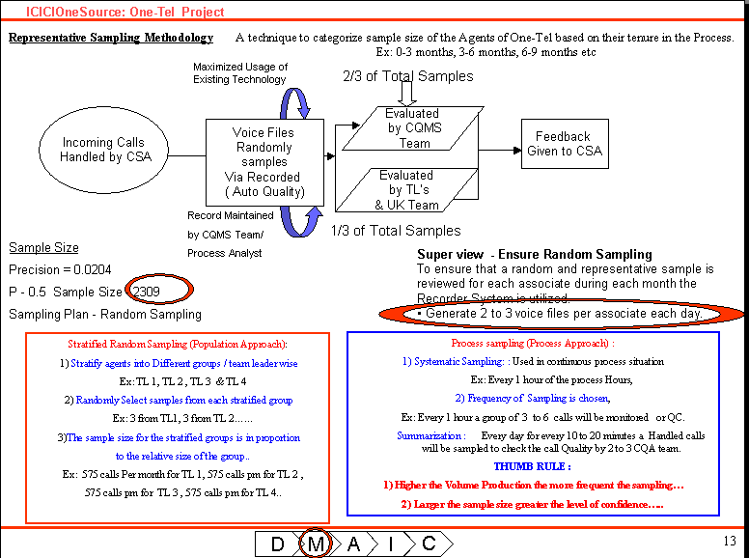

Sample Size
• Each CQA’s will evaluate 4 contacts per agent per week (approx 16 – 17 contacts per month) for all agents. For agents working different processes the sample will cover the range of work completed by the agent.
• At the end of the month, scores of different work stream per agent are merged to arrive at contact scores per agent and contact scores for different work streams and process scores.
• Each contact Quality Analyst to monitor 2 to 3 contacts per hour.
• CQA will start monitoring contacts from the last week of the training (called Intergration)

VOLUME OF CHECKS
Volume of checks should be the same for any agent on the programme regardless of the process on which they work.
Note: In cases where there is time available to complete more agent checks then this can be done but, only if the additional volume can be checked for all agents. In other words, if there is say an opportunity to do an extra 500 checks on a team of 300 agents this would not be acceptable since this would lead to some agents having a score based on 2 checks whereas other agent’s scores would be based on 1 check. Similarly, in a programme of 300 agents where there is time to complete a further 620 quality checks this should be completed because all agents will have a quality score based on 2 checks.
Work Streams |  | No of calls | no of calls mth | AHT | Analyze | Time in secs | Time | Feedback | Feedback | Total hours
  Agents
 |  |  |  |  |  |  | (hour) | (secs) | (hours) | Total hours
Customer Service | 71 | 284 | 1136 | 360 | 240 | 681600 | 189 | 681600 | 189.33 | 379
Collections | 50 | 200 | 800 | 135 | 240 | 300000 | 83 | 480000 | 133.33 | 217
Sales | 28 | 112 | 448 | 380 | 240 | 277760 | 77 | 268800 | 74.67 | 152
Provisioning | 43 | 172 | 688 | 468 | 240 | 487104 | 135 | 412800 | 114.67 | 250
Customer Service | 48 | 192 | 768 | 380 | 240 | 476160 | 132 | 460800 | 128.00 | 260
Total | 265 | 795 | 3498 |  |  |  |  |  | 132.5 | 1257
 |  |  |  |  |  |  |  |  |  | 7.6
CQA Calculation
No of wrkg hrs per day | 7.5
No of wrkg hrs per week | 37.5
No of call mon per hr | 2.65
No of call mon per day | 19.87
Tot no of call mon | 795
Time taken to mon | 15900 | (20 minutes per call
 |  | listening & Feedback) |  |  |  |  | 10.64
Convert 15900min to hrs | 265 | hours per week
No of cqa required
  7.6
CQA per seat ratio | 11

Note: The above-mentioned numbers in the table are assumptions of monitoring methods & numbers. Number of Contact Monitoring Per CQA will be 532.8 per month with an average monitoring ranging from 2 .2 to 3.2 contact monitoring per hour.

QUALTIY DURING MIGRATION
During the migration periods the expected quality scores will reflect a learning curve factor. The measures agreed and set for ‘business as usual’ will be used for quality measuring purposes i.e. the measures themselves will not be changed during the migration period. There will, however, be an amendment to the expected ‘pass’ scores for agent level quality reporting to take account of their learning curve. This covers a 5 week period where the target is set at various levels from 75%+ - 95%+.

The SLA Targets table below shows the quality monitoring and acceptable pass levels during agents first few weeks in the business.
 | Type of Monitoring | Volume by Week | Agent ‘Pass’ Level
Intergration  Training | CMA Remote monitoring | 4 per agent | 75%+ to move to live team
Intergration  Training | Side by side monitoring | 4 per agent | N/A Feedback only
Intergration  Training | Skimming by One.Tel | Ad Hoc | General feedback only
Live Week 1 | Floor Walk support | As required | N/A Feedback/ Coaching only
Live Week 1 | Side by side monitoring | 4 per agent | N/A Feedback/Coaching only
Live Week 1 | QMA Remote Monitoring | 4 per agent | 75% +
Live Week 1 | Skimming by One.Tel | Ad Hoc | General feedback only
Live Week 2 | TL coaching and side by side | As required | Direct Coaching feedback
Live Week 2 | QMA Remote Monitoring | 4 per agent | 80% +
Live Week 2 | Skimming by One.Tel | Ad Hoc | General feedback only
Live Week 3 | TL coaching and side by side | As required | Direct Coaching feedback
Live Week 3 | QMA Remote Monitoring | 4 per agent | 85% +
Live Week 4 | TL coaching and side by side | As required | Direct Coaching feedback
Live Week 4 | Remote Monitoring | 4 per agent | 90% +
Live Week 5 | TL coaching and side by side | As required | Direct Coaching feedback
Live Week 5 | QMA Remote Monitoring | 4 per agent | 90% +
Live Week 6 and ongoing | TL coaching and side by side | As required | Direct Coaching feedback
Live Week 6 and ongoing | QMA Remote Monitoring | 4 per agent | 95% +

QUALITY AFTER MIGRATION
Once a service element has been signed off, it is assumed that it is now business as usual (BAU). This milestone is at the end of a six week period, which starts from live date. An agents target for quality is set at 95%. Should an agent not be achieving this, it is assumed that the team leader will spend additional time with the agent to improve the areas highlighted in the scorecard. Should an agent not improve after two weeks, the trainer will be called in to offer additional training. This will take various forms including one on one training, revision on modules and the completion on specific set tasks.

CALIBRATION
OneTel and OneSource should calibrate the quality scores every two weeks(to be in line with the timings of weekly agent feedback). During migration there will be a daily calibration to focus on removing any defect as quickly as possible. We feel that, after 2 weeks, daily calibration will not be required. However should One.Tel or One source feel additional time be required for calibration either party can request a session. It is both parties goal to continue this exercise until the defect is less than 10%. Calibration sessions start when integration for the service element commences.

The approach to the calibration sessions include agreement on:
• To score calls which are ‘brand new’ (i.e. Not been listened to or marked previously) or to grade calls which have been used for the agent quality scores.
• The calls should be listened to as a group and everyone score together, discuss final scores and agree what the correct benchmark should be 5 to 10% deviation
• The number of calls could be up until consensus is reached or a regular volume of x calls
• The calls selected should focus on an area where a quality issue has been highlighted
Below is the process that will be used for obtaining quality calibration.
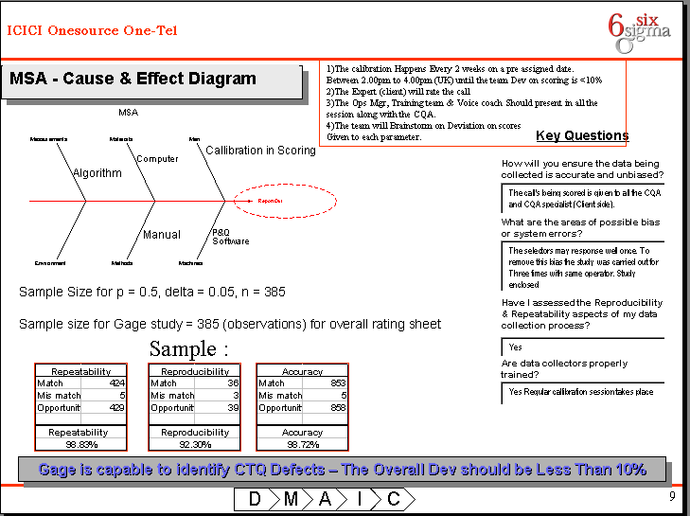

STRUCTURE OF THE CONTACT QUALITY MONITORING TEAM
The Contact Quality Monitoring team once ramped would have a position of Team Leader – Contact Quality Analyst. The span of control of the Team Leader - Contact Quality Analyst would be 1:15
The responsibility of staffing of the required Contact Quality Analyst would lie with the respective operations manager, as complete end-to-end process knowledge is a critical job skill set for the Contact Quality Analyst.
The quality team should be responsible for:
• Scheduling the volume and type of checks required to meet the above objectives for agent and process level checks
• Completing the checks as per their plan
• Taking corrective action on problems identified (agent/account level)
• Feeding back quality scores to individual agents in a timely manner
• Feeding back to Operations and Training any trends, which need addressing through revised training materials/modules etc.
• Feeding back to communications team items to be included in the daily or weekly briefing to operations.
• Developing, compiling and circulating all quality reports (agent reports, programmed reports etc.)
• Maintaining the suite of quality recording templates (i.e. templates will vary depending on the process being quality checked)
• The quality team should be tasked with constantly reviewing quality measurement criteria, making recommendations for changes and improvements and highlighting any quality focus areas – eg. XX was a problem this month so recommend that this is re-briefed to agents and that a failure with this field next month with mean a nil quality score for an agent
• Creating new and updating as required agent profiles in the Quality Monitoring Tool – Lotus Notes
• Assigning time for live work to be completed each calendar month to remain “up to speed and fresh” on the service element they are supporting.
• Support ad hoc quality drives

Reporting Line
The Contact Quality Analyst team will have an administrative line relationship with the Operations Manager of the Process and Black Belt will provide Coaching/Guidance on CQMS Process & its deployment for the One.Tel Operations.
The Operations/Quality Manager will be responsible to update and ensure that all relevant communications with respect to the process are marked to the Contact Quality Analyst / team as well.
The Contact Quality Analyst (team) in turn will be responsible to the Operations Manager & One-Tel, UK team to ensure on time reporting of all metrics and CQM done.
Contact Quality Analyst
Analyst Profile
• Have direct experience of data, sales or customer service
• Can demonstrate to an agent how to achieve a quality contact for the assigned service element.
• Are effective in giving direct feedback in a supportive and constructive way.
• Understands the impact of poor quality uses and is driven to deliver improvements in quality scores.
Required Skill Set
• Can demonstrate the role of the agent for the assigned service element
• Strong Process Knowledge
• Proficiency in MS Word, MS Excel, MS PowerPoint.
• Strong Analytical Skills
• Good Interpersonal Skills
• Ability to give Effective Feedback and coaching
• Proficiency in the Use of the Phone System (As Applicable)
• Strong Customer Service Orientation
• Ability to liaise with Clients
Role Outline
• Complete regular Contact Quality checks to support the sampling plan
• Complete the Quality Scorecard noting specific comments on
• Support the continuous improvement of agents quest for scoring excellence
• Complete 50 live contacts per month

Training Plan for Quality Analysts
All Contact Quality Analysts inducted in to the Contact Quality Monitoring System/team will undergo rigorous training to take on their new responsibilities. The Initial Training envisaged is as follows.
Serial No. | Training | Number of Hours | Criticality
1 | Yellow Belt orientation & Transaction Monitoring Using SIX SIGMA | 18 hours | High
2 | Training on Feedback Techniques | 6.30hrs | High
3 | Training on MSOffice/Minitab | 8 hrs | High
4 | Training on dash boarding and reporting | 4 hrs | High
5 | Production for 2 to 4 Hours/Week  (Back Office Operations) | 4 Hrs | High
6 | OneTel Communication training | 3days | High
7 | One.Tel Coaching training | 1 day | High
8 | Agent Foundation training | 10 day | High
9 | Agent specialist training (time various depending on course type) | 10-15 days | High
10 | One.Tel Quality Specialist Training | 3-5 days | High

Team Leader Role in Feedback Sessions
• Team Leaders should be responsible for agreeing any corrective action and training plans with individual agents
• Team Leaders should be responsible for overall team quality scores. They should be provided with a weekly-consolidated quality report showing their team statistics. Team Leaders will be targeted and measured on this.
• Team leaders should coach and complete side by side assessments with their team members and should provide instant feedback based on the quality scorecard criteria. Note: This feedback is an indication for the agent only.
• At the same time, each week team leaders should be provided with an overall team quality report (which does identify the individual quality scores) so that they can feedback team performance in the daily briefing. This will be an opportunity to acknowledge excellent performance as well as pick up any ‘quality themes’ eg. One thing the team have struggled on this week has been XXXX – lets run through the key points on that process again . . . In addition they should have visibility of the ‘volume quality check’ information (see below).

Seating Plan
It is proposed that all Contact Quality Analysts will be allocated seats in a single bay on the same floor as the process that they are aligned with. This will ensure close proximity with the process as well as best practice sharing within the CQMS team.
Note: 2 to 3 voice coaches to be there on the shop floor to assist Agents on Contact Quality.

TOOLS TO SUPPORT AND MEASURE CONTRACT QUALITY
100% of calls will be recorded at One.Tel. One. Source will record 25 % of the total calls to be used for Quality Monitoring. Should One. Source required other calls for quality purposes, access to One.Tel Eware systems will allow this. However selecting and playing these calls is recommended to be done outside of call centre customer office hours.
One. Source uses a scientifically & statistically valid tool called randomizer, select the agent for monitoring - randomly
Lotus Notes(LN) will provide an online score card for each service element. LN will allow for
• Agents details to be recorded including, name, alias, training completed, switch skill group etc
• Details of all contacts scored including specific feedback
• Various reporting views which includes:- past scores, rollup to team and service element level, weekly and monthly views etc
• Print agents scorecards etc is available but only out of call centre customer hours.
LN will be made available to the Quality Analysts and Team leaders.
Contact Quality Guidelines is a manual which can be used by agents and CQA to drill in specific areas listed in the scorecard. The guidelines outlines the meaning of the terms, examples and suggestions on how this can be demonstrated.

MONTHLY AUDITS
To improve our CQMS process month on month, audits on calls will be undertaken by the client if required.

MEETINGS, REVIEWS AND FEEDBACK
It is proposed that the CQAs have a conference call set up every week with the One.Tel Process Team/ Trainers and the UK Quality team (Service Observe) to review Quality and obtain updates. The I-One Operations Team will ensure that all updates are given immediately to agents and that there is no grace period on the same.
• All team feedback via the quality team will be done via the Daily Brief. This will include but not limited to areas of focus for teams and service elements
• Suggestions and scripts

ESCALLATION MATRIX FOR CONTACT MONITORING
In case of a dispute in call result the following is the escalation plan suggested
For internal failures
• First level of escalation – Team Leader
• Second level of escalation – Trainer
• Third level of escalation – CQA and UK Quality Lead (Service Observe)
For external failures
• First level of escalation – Team Leader
• Second level of escalation – Trainer and UK Quality Lead (Service Observe)
• Third level of escalation – Black Belt & One.Tel Process Specialist

BEST PRACTICES
One source will use the practices below to ensure a strong quality ethos and focus across the programme.
Action Lab
A review session every week on a pre-decided day where the discussion will be on contact Quality performance. The review session will be lead by the head Ops & Following his/her team. The rule of this basic Review is to ensure Call Quality & improvement plan in place & in tandem with the improvement plan.
Pinnacle Nest
A decorated Cubicle where the week top performer on Quality will be seated & take calls. An innovative idea to showcase the best performer to the process to the process & ultimately rewarding him with Six Sigma certificates & Gift Vouchers. The team leader will be getting 5 Bonus points in his/her appraisal.
Call of the Week
Each team leader should come out with the Best Calls of his/her team. The panel consists of Ops manager & QM to review the contested calls & vote the Best call & caller of the week & Caller’s team leader gets 5 Bonus points in his/her monthly appraisal. (Rule: If a team leader not coming out with the calls for the contest, there will be a deduction of 5 points in his/her monthly appraisal.) The Call will be measured on the basis of AHT Plus or minus 10secsof the calls, Quality, Compliance & Process procedures. These calls will be saved on in the Quality directory on the lan under \good calls.
Voice of the Week
The Call will be rewarded only on the Soft skill part of the call. The calls will be evaluated on the basis of Professionalism, Telephone etiquettes, Listening, Mannerism & Questioning & answering skills.
Call of Fame
The Individual who achieves the Highest Quality Monitoring Score for the month is awarded Rs/$ XXXamount.
Briefing & De- Briefing
The Individual Ops manager to start the day with a Briefing session on KPI’s performance, updates & review on previous day Quality scores (the source is the Agent Daily Breifing) . The Best Call & the agent to be rewarded/accolade for his/her performance on Quality. (Rule: Ops Manager should be present for the Briefing & De-briefing Session). The same applies at the end of the day.

CORRECTIVE ACTION PLAN FOR IMPROVEMENT ON CONTACT QUALITY
Customer Account Level
Where errors are identified during the quality check process the Quality agents should be responsible for taking corrective action if it is customer/client impacting. E.g. amending a tariff code which has been keyed incorrectly by an agent

