kolb learning styles

David Kolb's learning styles model and experiential learning theory (ELT)
Having developed the model over many years prior, David Kolb published his learning styles model in 1984. The model gave rise to related terms such as Kolb's experiential learning theory (ELT), and Kolb's learning styles inventory (LSI). In his publications - notably his 1984 book 'Experiential Learning: Experience As The Source Of Learning And Development' Kolb acknowledges the early work on experiential learning by others in the 1900's, including Rogers, Jung, and Piaget. In turn, Kolb's learning styles model and experiential learning theory are today acknowledged by academics, teachers, managers and trainers as truly seminal works; fundamental concepts towards our understanding and explaining human learning behaviour, and towards helping others to learn. See also Gardner's Multiple Intelligences and VAK learnings styles models, which assist in understanding and using Kolb's learning styles concepts.
In addition to personal business interests (Kolb is founder and chairman of Experience Based Learning Systems), David Kolb is still (at the time I write this, 2005) Professor of Organizational Development at Case Western Reserve University, Cleveland, Ohio, where he teaches and researches in the fields of learning and development, adult development, experiential learning, learning style, and notably 'learning focused institutional development in higher education'.

kolb's experiential learning theory (learning styles) model
Kolb's learning theory sets out four distinct learning styles (or preferences), which are based on a four-stage learning cycle. (which might also be interpreted as a 'training cycle'). In this respect Kolb's model is particularly elegant, since it offers both a way to understand individual people's different learning styles, and also an explanation of a cycle of experiential learning that applies to us all.
Kolb includes this 'cycle of learning' as a central principle his experiential learning theory, typically expressed as four-stage cycle of learning, in which 'immediate or concrete experiences' provide a basis for 'observations and reflections'. These 'observations and reflections' are assimilated and distilled into 'abstract concepts' producing new implications for action which can be 'actively tested' in turn creating new experiences.
Kolb says that ideally (and by inference not always) this process represents a learning cycle or spiral where the learner 'touches all the bases', ie., a cycle of experiencing, reflecting, thinking, and acting. Immediate or concrete experiences lead to observations and reflections. These reflections are then assimilated (absorbed and translated) into abstract concepts with implications for action, which the person can actively test and experiment with, which in turn enable the creation of new experiences.
Kolb's model therefore works on two levels - a four-stage cycle:
- Concrete Experience - (CE)
- Reflective Observation - (RO)
- Abstract Conceptualization - (AC)
- Active Experimentation - (AE)
and a four-type definition of learning styles, (each representing the combination of two preferred styles, rather like a two-by-two matrix of the four-stage cycle styles, as illustrated below), for which Kolb used the terms:
- Diverging (CE/RO)
- Assimilating (AC/RO)
- Converging (AC/AE)
- Accommodating (CE/AE)

diagrams of kolb's learning styles
Here is a new improved (May 2006) free diagram illustrating Kolb's learning cycle and learning types (MSWord). (Also as a pdf.)
Kolb diagrams also in colour (like the image below): Kolb learning styles colour diagram MSWord, and Kolb colour diagram PDF.
(Kolb diagrams updated May 2006)

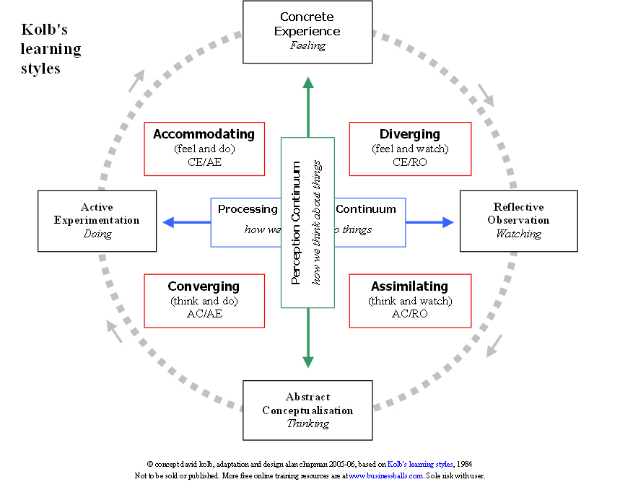

See also the personality styles and models section for help with understanding how Kolb's theory correlates with other personality models and psychometrics (personality testing).

learning styles
(This interpretation was amended and revised March 2006)
Kolb explains that different people naturally prefer a certain single different learning style. Various factors influence a person's preferred style: notably in his experiential learning theory model (ELT) Kolb defined three stages of a person's development, and suggests that our propensity to reconcile and successfully integrate the four different learning styles improves as we mature through our development stages. The development stages that Kolb identified are:
- Acquisition - birth to adolescence - development of basic abilities and 'cognitive structures'
- Specialization - schooling, early work and personal experiences of adulthood - the development of a particular 'specialized learning style' shaped by 'social, educational, and organizational socialization'
- Integration - mid-career through to later life - expression of non-dominant learning style in work and personal life.
Whatever influences the choice of style, the learning style preference itself is actually the product of two pairs of variables, or two separate 'choices' that we make, which Kolb presented as lines of axis, each with 'conflicting' modes at either end:
Concrete Experience - CE (feeling) -----V-----Abstract Conceptualization - AC (thinking)
Active Experimentation - AE (doing)-----V----- Reflective Observation - RO (watching)
A typical presentation of Kolb's two continuums is that the east-west axis is called the Processing Continuum (how we approach a task), and the north-south axis is called the Perception Continuum (our emotional response, or how we think or feel about it).
These learning styles are the combination of two lines of axis (continuums) each formed between what Kolb calls 'dialectically related modes' of 'grasping experience' (doing or watching), and 'transforming experience' (feeling or thinking):

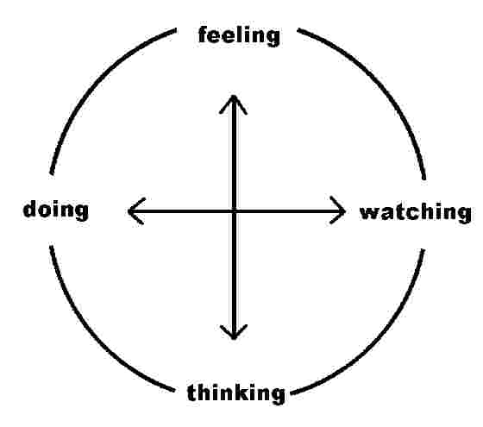

The word 'dialectically' is not widely understood, and yet carries an essential meaning, namely 'conflicting' (its ancient Greek root means 'debate' - and I thank P Stern for helping clarify this precise meaning). Kolb meant by this that we cannot do both at the same time, and to an extent our urge to want to do both creates conflict, which we resolve through choice when confronted with a new learning situation. We internally decide whether we wish to do or watch, and at the same time we decide whether to think or feel.
The result of these two decisions produces (and helps to form throughout our lives) the preferred learning style, hence the two-by-two matrix below. We choose a way of 'grasping the experience', which defines our approach to it, and we choose a way to 'transform the experience' into something meaningful and usable, which defines our emotional response to the experience. Our learning style is a product of these two choice decisions:
- how to approach a task - ie., 'grasping experience' - preferring to (a) watch or (b) do , and
- our emotional response to the experience - ie., 'transforming experience' - preferring to (a) think or (b) feel.

In other words we choose our approach to the task or experience ('grasping the experience') by opting for 1(a) or 1(b):
- 1(a) - though watching others involved in the experience and reflecting on what happens ('reflective observation' - 'watching') or
- 1(b) - through 'jumping straight in' and just doing it ('active experimentation' - 'doing')
And at the same time we choose how to emotionally transform the experience into something meaningful and useful by opting for 2(a) or 2(b):
- 2(a) - through gaining new information by thinking, analyzing, or planning ('abstract conceptualization' - 'thinking') or
- 2(b) - through experiencing the 'concrete, tangible, felt qualities of the world' ('concrete experience' - 'feeling')
The combination of these two choices produces a preferred learning style. See the matrix below.

kolb's learning styles - matrix view
It's often easier to see the construction of Kolb's learning styles in terms of a two-by-two matrix. The diagram also highlights Kolb's terminology for the four learning styles; diverging, assimilating, and converging, accommodating:

 | doing (Active Experimentation - AE) | watching (Reflective Observation - RO)
feeling (Concrete Experience - CE) | accommodating (CE/AE) | diverging (CE/RO)
thinking (Abstract Conceptualization - AC) | converging (AC/AE) | assimilating (AC/RO)

Thus, for example, a person with a dominant learning style of 'doing' rather than 'watching' the task, and 'feeling' rather than 'thinking' about the experience, will have a learning style which combines and represents those processes, namely an 'Accommodating' learning style, in Kolb's terminology.

kolb learning styles definitions and descriptions
Knowing a person's (and your own) learning style enables learning to be orientated according to the preferred method. That said, everyone responds to and needs the stimulus of all types of learning styles to one extent or another - it's a matter of using emphasis that fits best with the given situation and a person's learning style preferences.
Here are brief descriptions of the four Kolb learning styles:
- Diverging (feeling and watching - CE/RO) - These people are able to look at things from different perspectives. They are sensitive. They prefer to watch rather than do, tending to gather information and use imagination to solve problems. They are best at viewing concrete situations several different viewpoints. Kolb called this style 'Diverging' because these people perform better in situations that require ideas-generation, for example, brainstorming. People with a Diverging learning style have broad cultural interests and like to gather information. They are interested in people, tend to be imaginative and emotional, and tend to be strong in the arts. People with the Diverging style prefer to work in groups, to listen with an open mind and to receive personal feedback.
- Assimilating (watching and thinking - AC/RO) - The Assimilating learning preference is for a concise, logical approach. Ideas and concepts are more important than people. These people require good clear explanation rather than practical opportunity. They excel at understanding wide-ranging information and organising it a clear logical format. People with an Assimilating learning style are less focused on people and more interested in ideas and abstract concepts. People with this style are more attracted to logically sound theories than approaches based on practical value. These learning style people is important for effectiveness in information and science careers. In formal learning situations, people with this style prefer readings, lectures, exploring analytical models, and having time to think things through.
- Converging (doing and thinking - AC/AE) - People with a Converging learning style can solve problems and will use their learning to find solutions to practical issues. They prefer technical tasks, and are less concerned with people and interpersonal aspects. People with a Converging learning style are best at finding practical uses for ideas and theories. They can solve problems and make decisions by finding solutions to questions and problems. People with a Converging learning style are more attracted to technical tasks and problems than social or interpersonal issues. A Converging learning style enables specialist and technology abilities. People with a Converging style like to experiment with new ideas, to simulate, and to work with practical applications.
- Accommodating (doing and feeling - CE/AE) - The Accommodating learning style is 'hands-on', and relies on intuition rather than logic. These people use other people's analysis, and prefer to take a practical, experiential approach. They are attracted to new challenges and experiences, and to carrying out plans. They commonly act on 'gut' instinct rather than logical analysis. People with an Accommodating learning style will tend to rely on others for information than carry out their own analysis. This learning style is prevalent and useful in roles requiring action and initiative. People with an Accommodating learning style prefer to work in teams to complete tasks. They set targets and actively work in the field trying different ways to achieve an objective.

As with any behavioural model, this is a guide not a strict set of rules.
Nevertheless most people clearly exhibit clear strong preferences for a given learning style. The ability to use or 'switch between' different styles is not one that we should assume comes easily or naturally to many people.
Simply, people who have a clear learning style preference, for whatever reason, will tend to learn more effectively if learning is orientated according to their preference.
For instance - people who prefer the 'Assimilating' learning style will not be comfortable being thrown in at the deep end without notes and instructions.
People who like prefer to use an 'Accommodating' learning style are likely to become frustrated if they are forced to read lots of instructions and rules, and are unable to get hands on experience as soon as possible.

relationships between kolb and other behavioural/personality theories
As with many behavioural and personality models, interesting correlations exist between Kolb's theory and other concepts.
For example, Kolb says that his experiential learning theory, and therefore the learning styles model within it, builds on Carl Jung's assertion that learning styles result from people's preferred ways of adapting in the world.
Among many other correlations between definitions, Kolb points out that Jung's 'Extraversion/Introversion' dialectical dimension - (which features and is measured in the Myers-Briggs Type Indicator [MBTI]) correlates with the 'Active/Reflective' (doing/watching) dialectic (east-west continuum) of Kolb's model.
Also, the MBTI 'Feeling/Thinking' dimension correlates with the Kolb model Concrete Experience/Abstract Conceptualization dimension (north-south continuum).

honey and mumford's variation on the kolb system
Various resources (including this one in the past) refer to the terms 'activist', 'reflector', 'theorist', and 'pragmatist' (respectively representing the four key stages or learning steps) in seeking to explain Kolb's model. In fact, 'activist', 'reflector', 'theorist', and 'pragmatist' are from a learning styles model developed by Honey and Mumford, which although based on Kolb's work, is different. Arguably therefore the terms 'activist', 'reflector', 'theorist', and 'pragmatist' effectively 'belong' to the Honey and Mumford theory.
Peter Honey and Alan Mumford developed their learning styles system as a variation on the Kolb model while working on a project for the Chloride corporation in the 1970's. Honey and Mumford say of their system:
"Our description of the stages in the learning cycle originated from the work of David Kolb. Kolb uses different words to describe the stages of the learning cycle and four learning styles..."
And, "...The similarities between his model and ours are greater than the differences.." (Honey & Mumford)
In summary here are brief descriptions of the four H&M key stages/styles, which incidentally are directly mutually corresponding and overlaid, as distinct from the Kolb model in which the learning styles are a product of combinations of the learning cycle stages. The typical presentation of these H&M styles and stages would be respectively at north, east, south and west on a circle or four-stage cyclical flow diagram.
- 'Having an Experience' (stage 1), and Activists (style 1): 'here and now', gregarious, seek challenge and immediate experience, open-minded, bored with implementation.
- 'Reviewing the Experience' (stage 2) and Reflectors (style 2): 'stand back', gather data, ponder and analyse, delay reaching conclusions, listen before speaking, thoughtful.
- 'Concluding from the Experience' (stage 3) and Theorists (style 3): think things through in logical steps, assimilate disparate facts into coherent theories, rationally objective, reject subjectivity and flippancy.
- 'Planning the next steps' (stage 4) and Pragmatists (style 4): seek and try out new ideas, practical, down-to-earth, enjoy problem solving and decision-making quickly, bored with long discussions.
There is arguably a strong similarity between the Honey and Mumford styles/stages and the corresponding Kolb learning styles:
- Activist = Accommodating
- Reflector = Diverging
- Theorist = Assimilating
- Pragmatist = Converging

Concrete Experience
Feeling

Perception Continuum

how we think about things
Kolb's learning styles
Reflective Observation Watching
Active Experimentation Doing
Abstract Conceptualisation Thinking

Processing Continuum

how we do things

Assimilating
(think and watch)
AC/RO

Diverging
(feel and watch)
CE/RO

Converging
(think and do)
AC/AE

Accommodating
(feel and do)
CE/AE

