WHO: |  | Review Date: | SELF EVALUATION  For Mid-Year and Annual Evaluations
NAME/EMPLOYEE #
JOB TITLE
MANAGER
REVIEW PERIOD |  | From: To:
WHAT: | True North for your area of responsibility  while helping the bigger team win |  |  | HOW: | Refer to the Leadership Success Profile,  Job Profile for position, and the Intuit Values
What is Important (Goals) |  |  |  | Methodology, Skills, Mindset, Values
True North for your area of responsibility (clearly stated) |  |  |  | Strengths – Methodology, skills, mindset, and values that enabled great results; leverage these more (give examples)  Improvement Opportunities – Methodology, skills, mindset, and values that were barriers to achieving great results; minimize these (give examples)
What Were the Results (Outcomes)
Qualitative and quantitative outcomes for all three stakeholders (employees, customers, shareholders) across the short and long term

Qualitative outcomes for:
- Role modeling/growing leadership capabilities
- Engagement that contributes to team performance

OVERALL RATING:
Ratings Criteria: 1=Exceptional Performance,
2=Consistently Exceeds Expectations, 3=Meets Expectations, 4=Inconsistent Performer, 5=Consistently Below Expectations
REFERENCE MATERIALS:
These are elements of a successful performance management process.
(Refer to the intranet for more information)
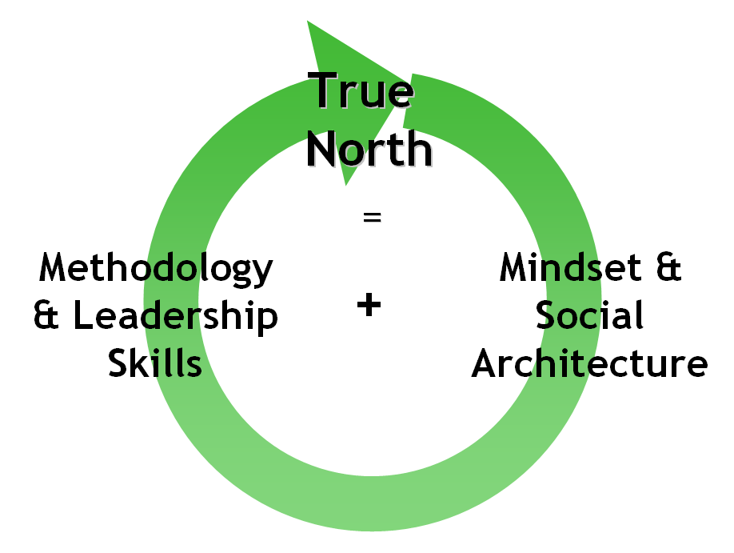
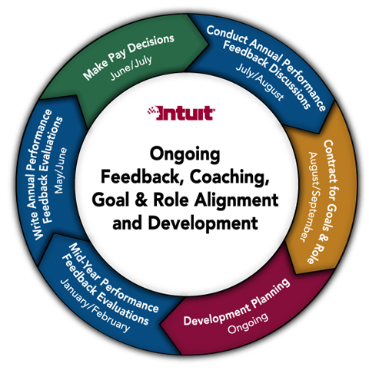
Leadership Success Profile
Steve’s
Dream
Apply
Business Acumen
Lead
Change… Courage
Execute
Effectively
Build
Strong Teams
How We Behave…
Culture/Social Architecture
LEARN THEN TEACH

